**Exp 4)** Create a simple cloud software application for Library book reservation system for SIMATS library using any Cloud Service Provider to demonstrate SaaS include the necessary fields such as Title of the book, author, publications

**PROCEDURE:**

**STEP1:** GOTO ZOHO.COM

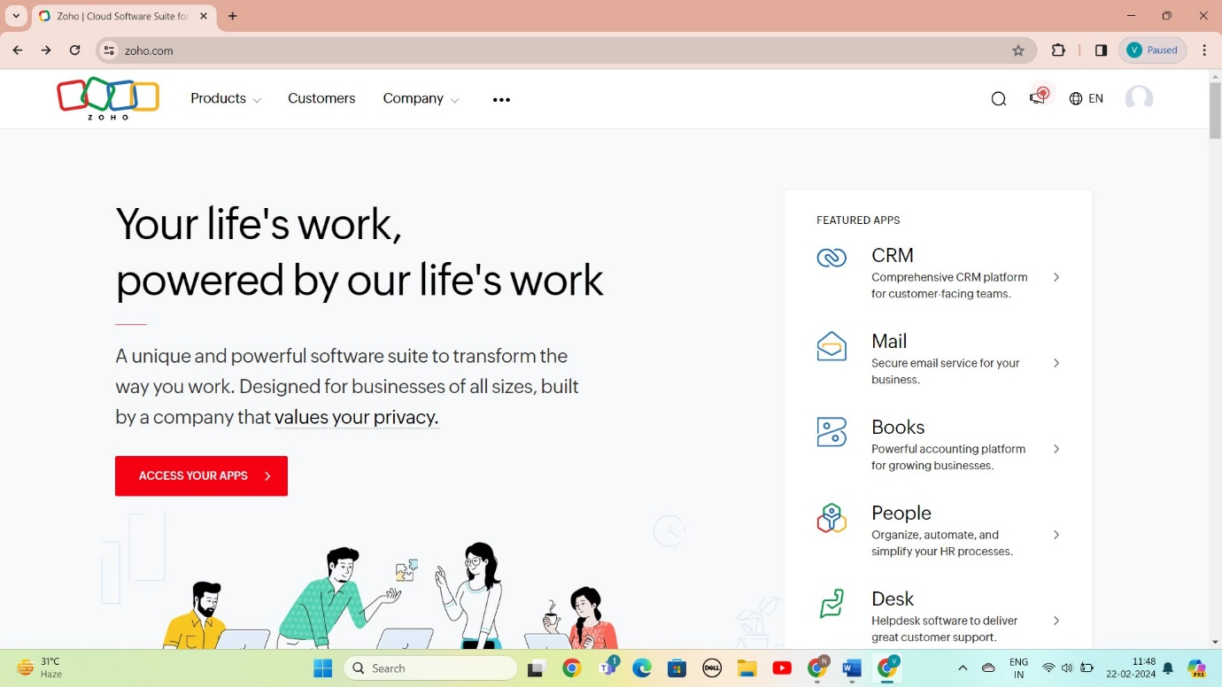

STEP 2: LOGIN TO THE ZOHO.COM

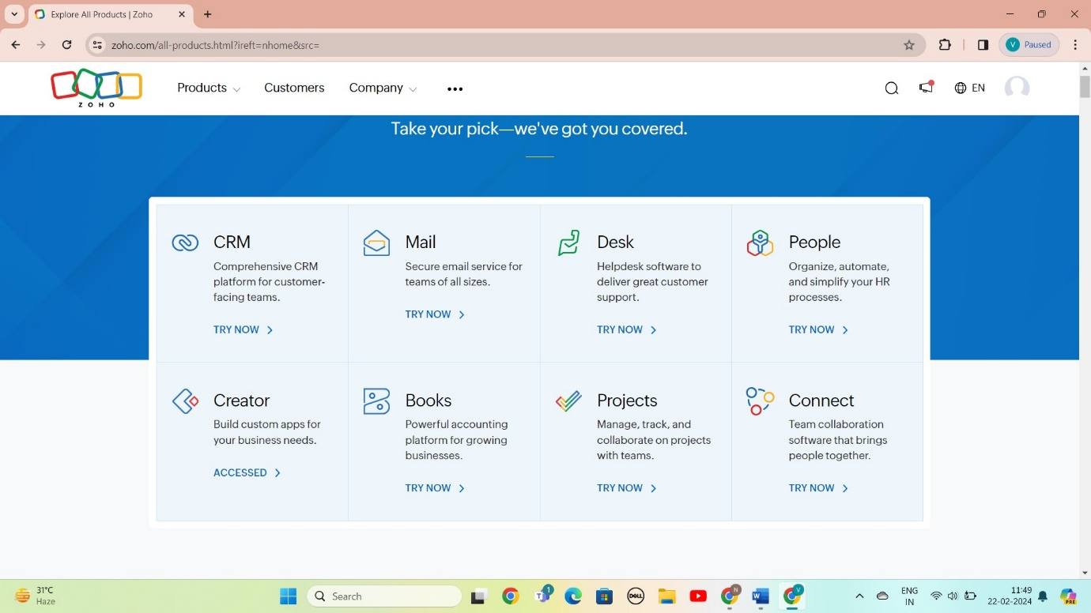

STEP 3: SELECT A CREATE FROM SCRATCH

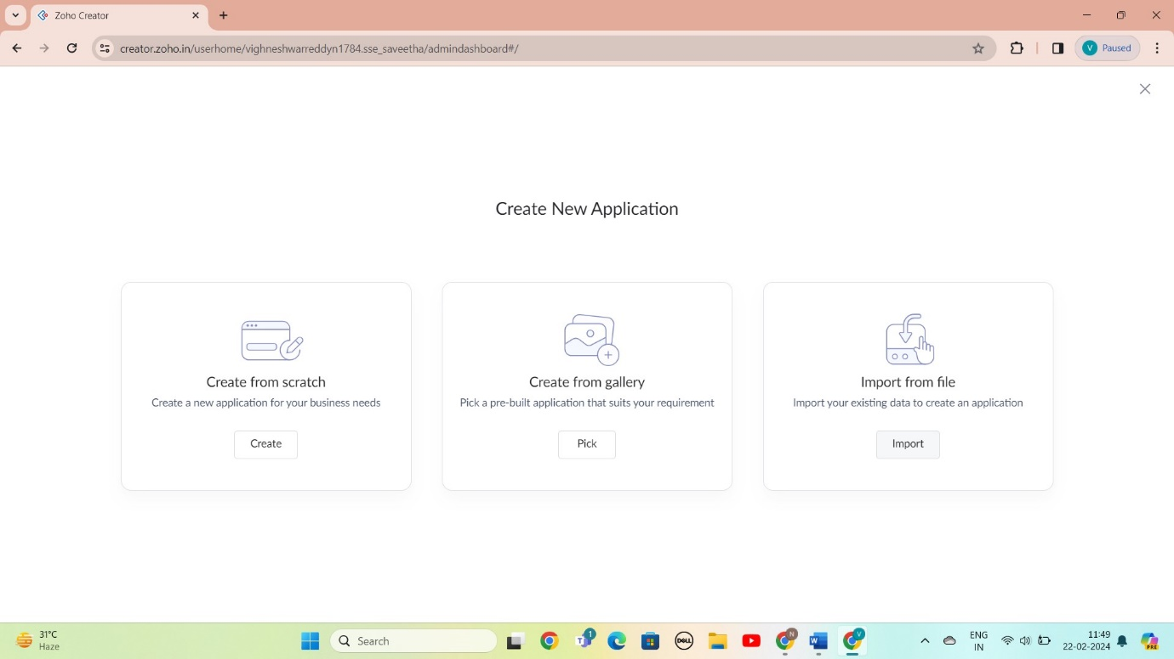

STEP 4: SELECT APPLICATION NAME AS Library book reservation system

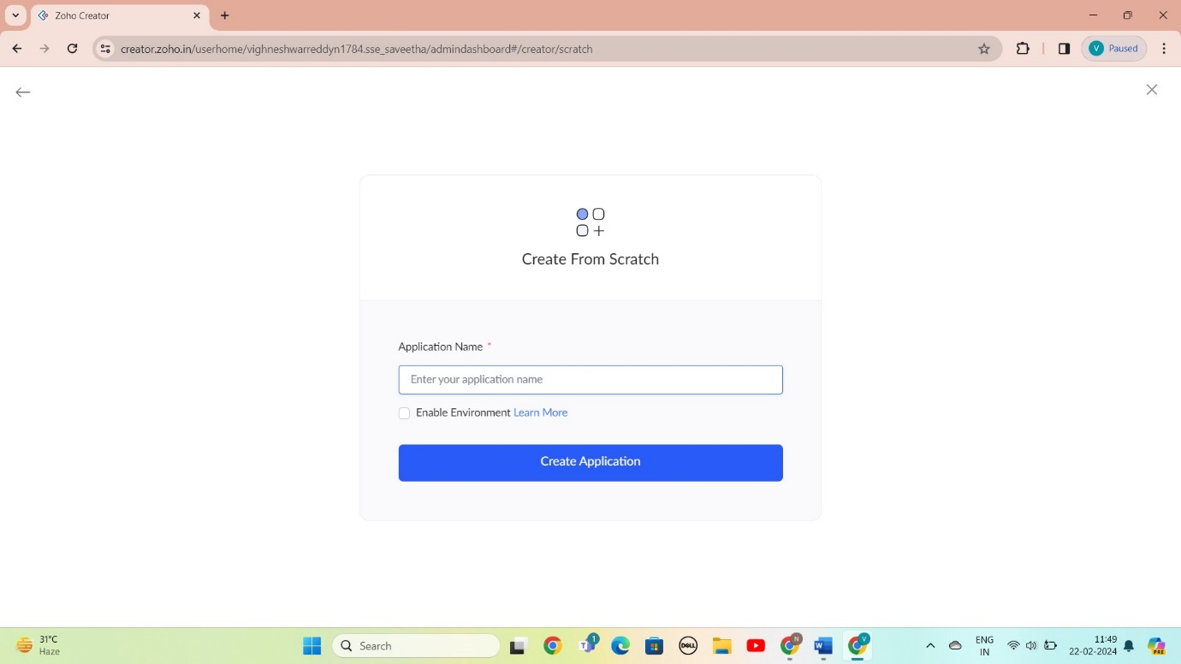

STEP 5: CREATED NEW FORM

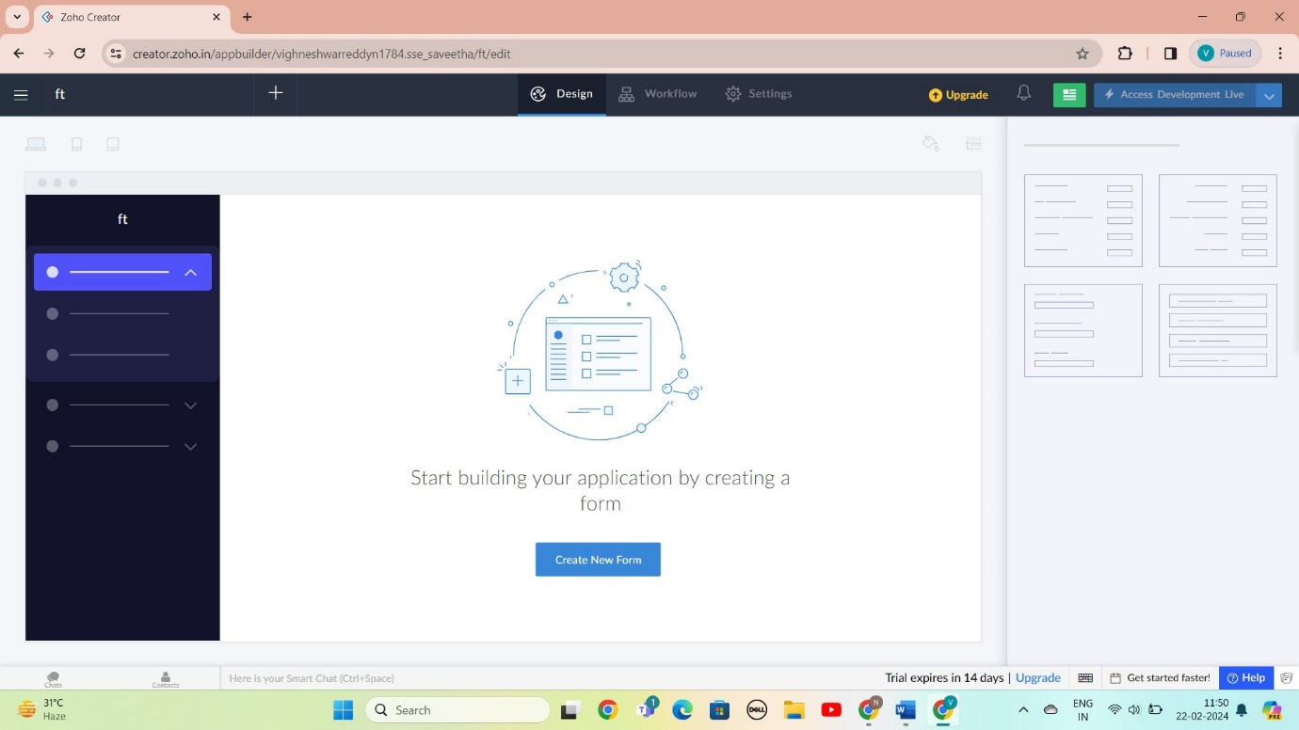

STEP 6: SELECT BASIC FILED FROM GIVEN BELOW AND DEVELOP APPLICATION

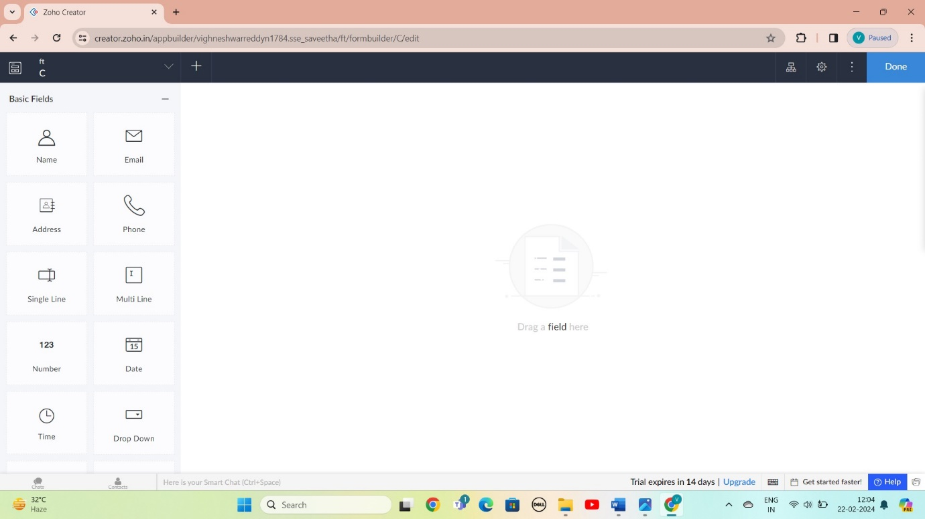

STEP 7: THE SOFTWARE AS BEEN CREATE LOGIN

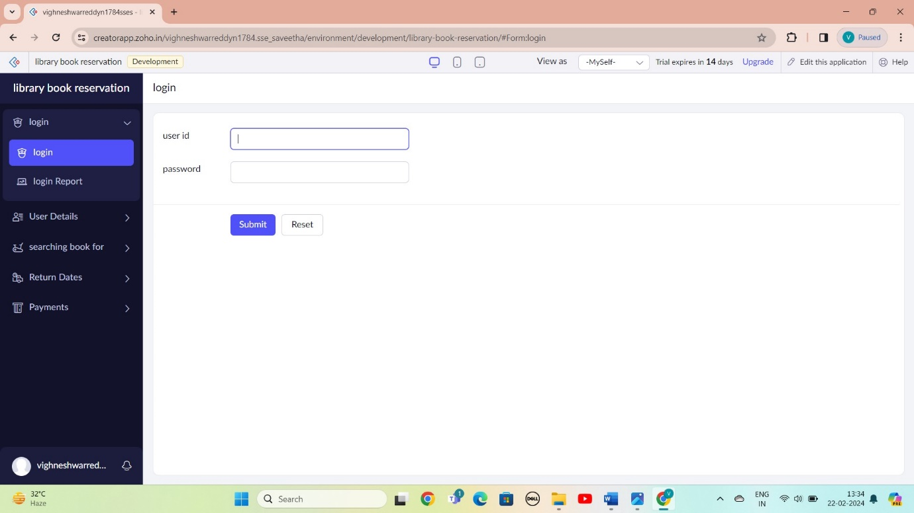

STEP 8: THE SOFTWARE AS BEEN CREATE USER DETAILS

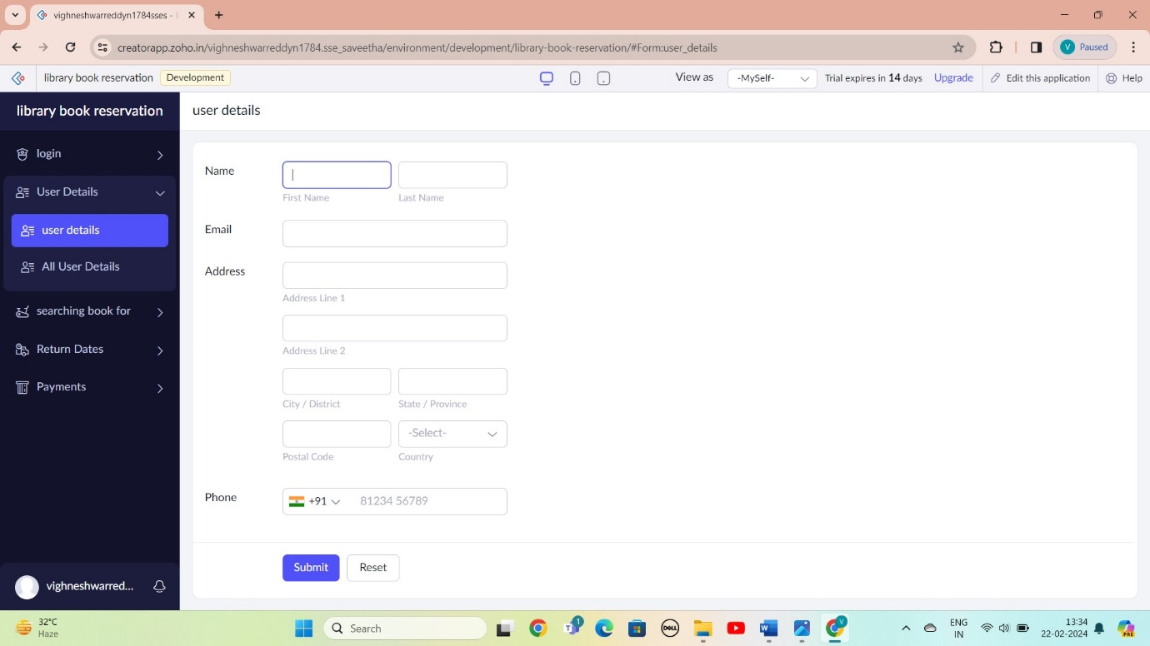

STEP 9: THE SOFTWARE AS BEEN CREATE SEARCHING FOR BOOK

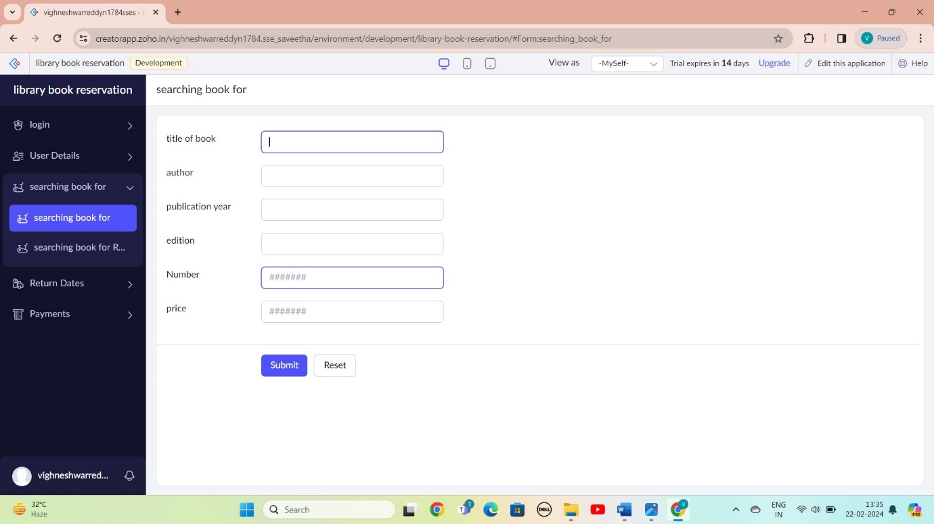

STEP 10: THE SOFTWARE AS BEEN CREATE BOOK RETURN DATE

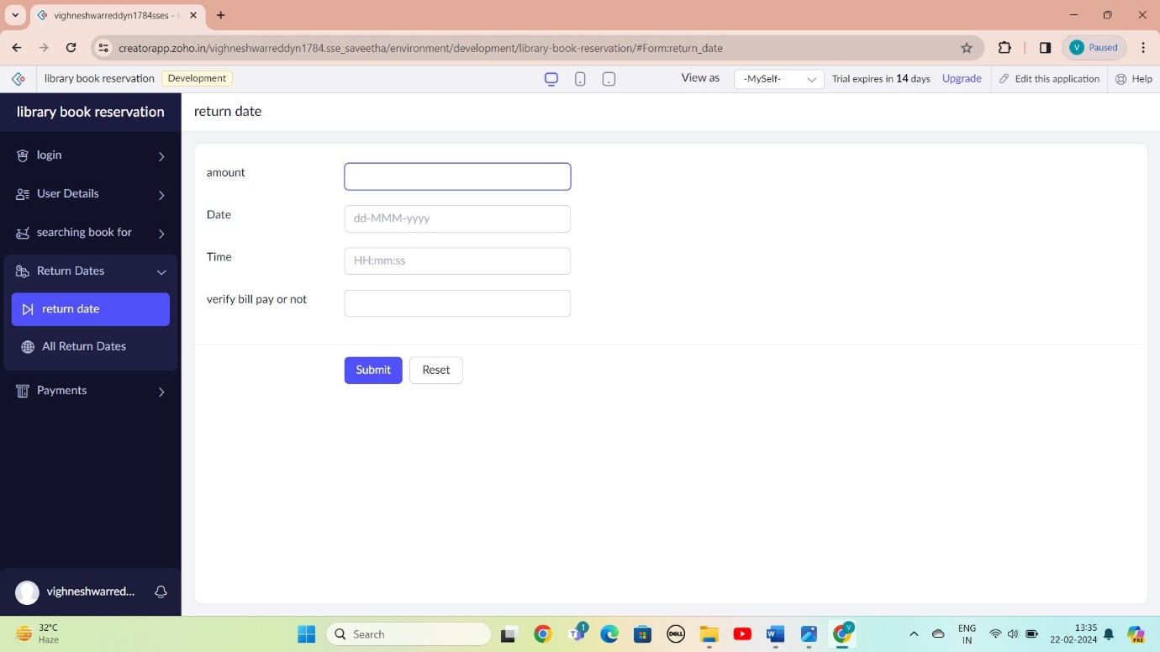

STEP 11: THE SOFTWARE AS BEEN CREATE PAYMENTS

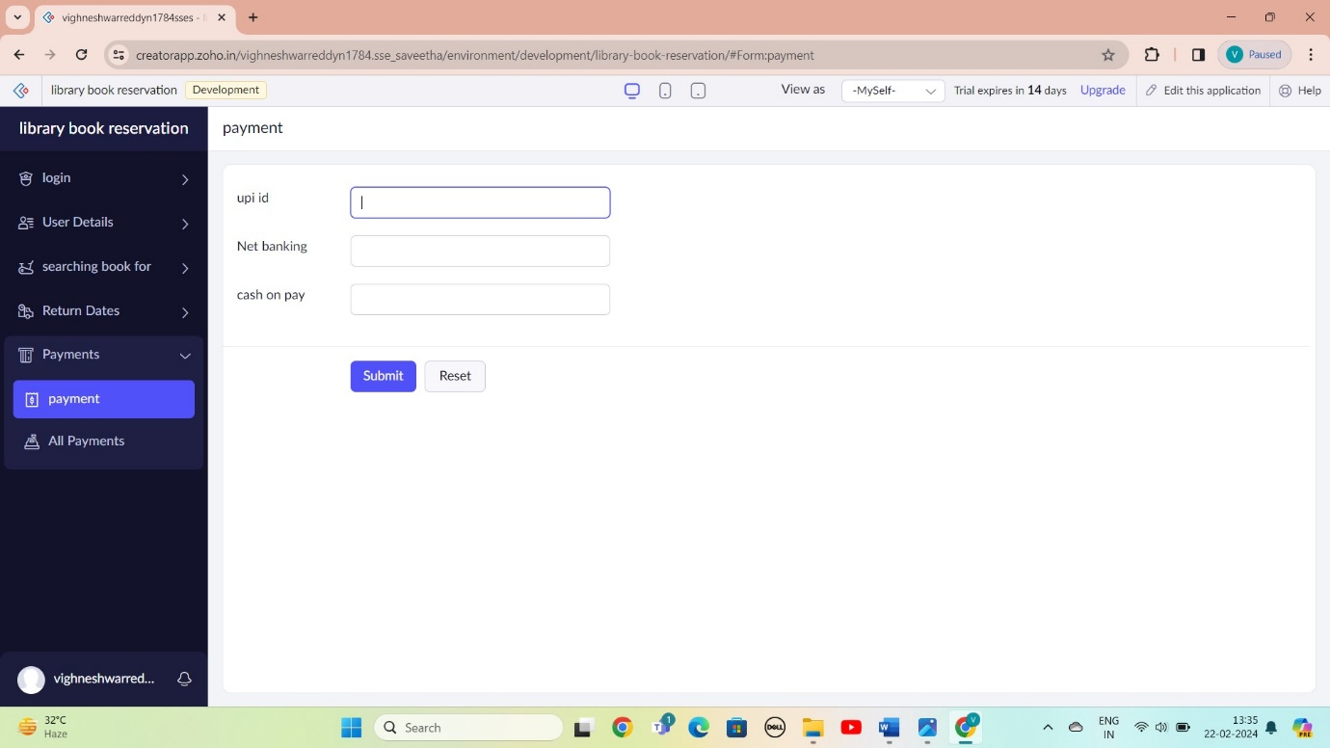

STEP 11: THE SOFTWARE AS BEEN CREATE

